**What is Solana?**

Solana is a decentralized platform for executing smart contracts, very similar to Ethereum - only it is called a high-speed blockchain.

With the innovation of combining Proof of Stake and Proof of History, the system can carry out up to 50,000 transactions per second at extremely low fees and is therefore considered a strong competitor to Ethereum.

SOL is the name of the native coin of the Solana blockchain.

What do you need the Solana Coin (SOL) for?

* staking
* Transaction fees (e.g. for executing smart contracts)
* governance

**Goal of Solana ?**

All blockchains must deal with a solution to the trilemma "decentralization - security - scalability"(see Abb.1). Many only manage to combine two. With Bitcoin and Ethereum, for example, it is decentralization and security, but the networks are very slow and the transactions are expensive and only scalable to a limited extent.

Solana speaks of itself as perfectly combining the 3 properties - like no other blockchain. 50,000 transactions per second are possible, more than 100,000 transactions per second are planned in the future, the platform itself should be absolutely decentralized and secure.

Solana is therefore also very well suited for decentralized apps (dApps) and decentralized exchanges (DEX)

Fig.1: Blockchain trilemma

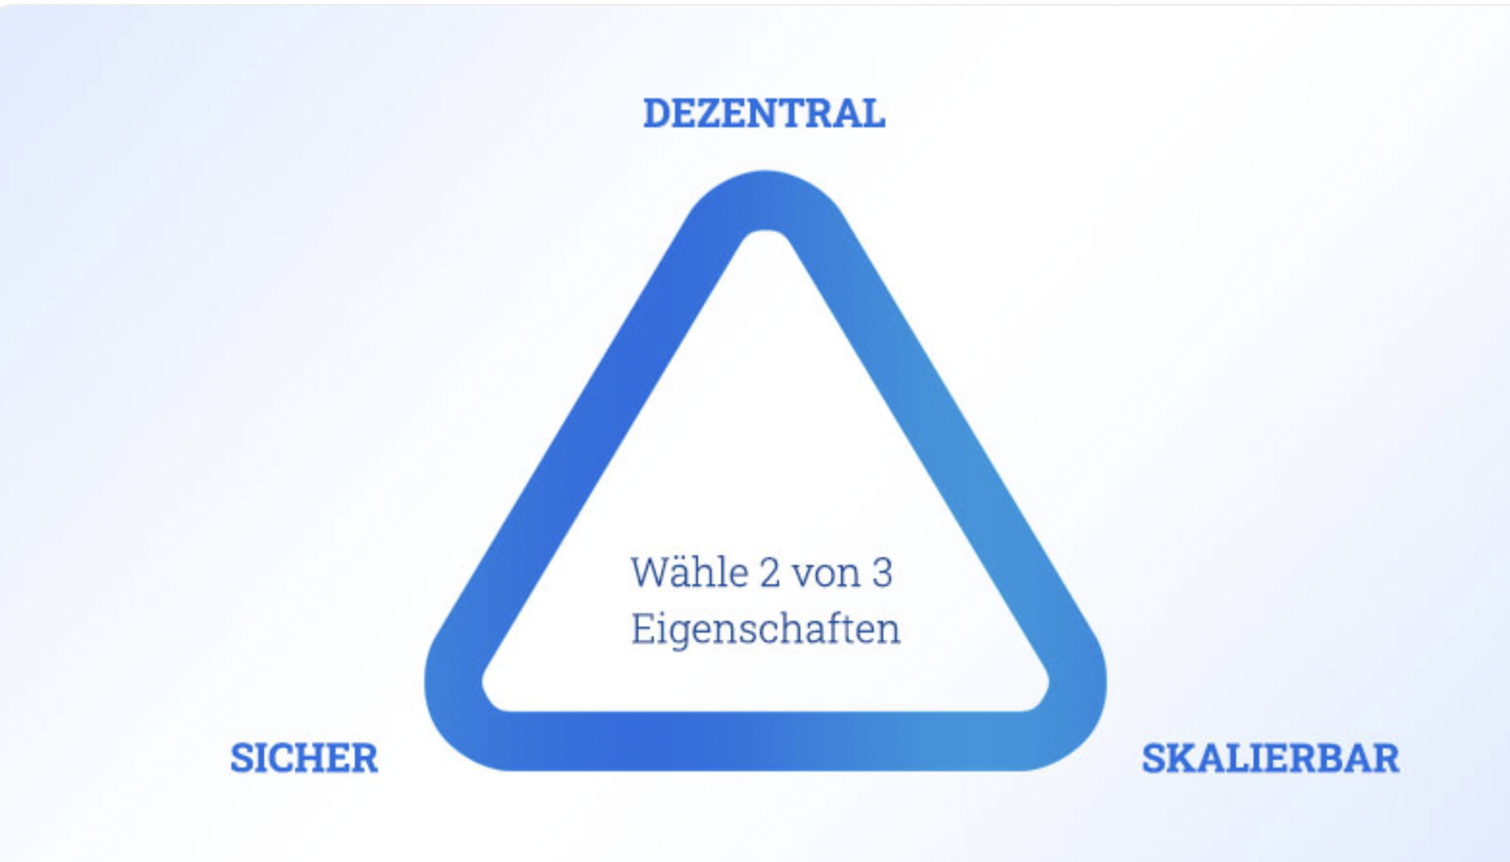

Solana Facts

| Symbol | SOL |
| --- | --- |
| Konsens Algorithmus | Proof of Stake & Proof of History |
| Founder | Anatoly Yakovenko, Raj Gokal |
| Publication | 2017, Handelsstart 2020 |
| Max | 489 Mio (ohne Gewähr) |
| Market Capitalisation | 30.516.675.949,69 € |
| ATH (06.11.21) | $259.96 |
| Use Case | Infrastructur, Smart Contracts, DApps |